**“SIGN LANGUAGE DETECTION”**

Synopsis

Submitted for Registration as a research student for the degree of Bachelor of Engineering in Information Technology

By

# Ms. Pallavi Maske Ms. Sonali Patil

**Mr. Chandrakant Prajapati Ms. Achal Butke**

Under the guidance of

**Prof. Priyanka**

Submitted to

Rashtrasant Tukadoji Maharaj Nagpur University, Nagpur

(Faculty of Engineering and Technology)

**Abstract :**

The Sign Language is a derived language for communication between deaf and dumb people. A Sign Language is one of the ways to communicate with deaf people. Every country has introduced its own sign language. The sign language developed in India is known as Indian Sign Language (ISL). The sign language is most reliable and significant way of communication between normal people and hard of hearing and speech impaired people without the need of interpreter. One should learn sign language to interact with them. In this paper, we present a literature of the latest advancements in the area of sign language (recognition). First, we review the techniques of gesture recognition and highlight some critical and important methods in recent developments. Next, we focus on the analysis and discussions about the challenges and any other possible solutions for the sign language recognition. We propose a method to create an Indian Sign Language dataset using a webcam and then using transfer learning, train a TensorFlow model to create a real-time Sign Language Recognition system.

**Title:** "Sign Language detection "

**Introduction:**

# The Sign Language is a derived language for communication between deaf and dumb people. A Sign Language is one of the ways to communicate with deaf people. Every country has introduced its own sign language. The sign language developed in India is known as Indian Sign Language (ISL). The sign language is most reliable and significant way of communication between normal people and hard of hearing and speech impaired people without the need of interpreter. One should learn sign language to interact with them. In this paper, we present a literature of the latest advancements in the area of sign language (recognition). First, we review the techniques of gesture recognition and highlight some critical and important methods in recent developments. Detection of Hand Gesture Regions, Aim to fix on the valid frames and locate the hand region from the rest of the image. Next, we focus on the analysis and discussions about the challenges and any other possible solutions for the sign language recognition. We propose a method to create an Indian Sign Language dataset using a webcam and then using transfer learning, train a TensorFlow model to create a real-time Sign Language Recognition system. understand what the other wants to convey. The purpose of sign language detection system is to provide an efficient and accurate way to convert language into text messages. The system has a huge future scope as it makes communication more efficient and easier. This promotes cultural awareness, literacy, and other intellectual benefits.

# One of its primary goals is to create this SL systems, which can identify specific gestures and use them to convey information or to control a device. Though, gestures need to be modelled in the spatial and temporal domains, where a hand posture is the static structure of the hand and a gesture is the dynamic movement of the hand.

# Sign language consists of vocabulary of signs in exactly the same way as spoken language consists of a vocabulary of words. Sign languages are not standard and universal and the grammars differ from country to country.

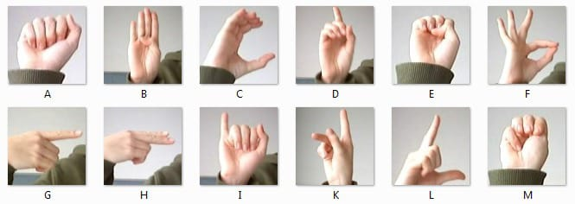

**2) Brief Literature Survey :**

* Gesture Recognitions and Sign Language recognition has been a well researched
* Few research works have been carried out in Sign Language using image processing/vision techniques.
* Most of the previous works found either analyzed what features could be better for analysis or reported results for a subset of the alphabets

In Literature Review, We Studied about existing project related to this topic and try to understand about existing system behaviour.

**Paper [1]:-** J. Ekbote and M. Joshi. "Indian sign language recognition using ANN and SVM classifiers have proposed the method in which system has four major developmental stages which include preprocessing, segmentation, feature extraction and classification, which show that the recognition system is capable of recognizing the Amharic alphabet signs with an average accuracy.

.

# Paper [2] :- P.C. Badhe and V. Kulkarni, "Indian sign language translator using gesture recognition algorithm,"

# This paper presents a survey on various sign recognition approaches for ISL and reports on the works reported for dynamic gesture recognition of ISL.

# Paper [3] :- Deaf Mute Communication Interpreter- A Review [1] : This paper aims to cover the various preailing methods of deaf-mute communication interpreter system. The two broad classification of the communication methodologies used by the deaf mute people are – Wearable Communication Device and Online Learning System. Under Wearable communication method, there are Glove based system, Keypad method and Handicom Touch-screen. All the above mentioned three sub- divided methods make use of various sensors, accelerometer, a suitable micro-controller, a text to speech conversion module, a keypad and a touch-screen. The need for an external device to interpret the message between a deaf mute and non-deaf-mute

# people can be overcome by the second method i.e., online learning system The Online Learning System has different methods. The five subdivided methods are- SLIM module, TESSA, Wi-See Technology, SWI_PELE System and Web- Sign Technology.

## 3) Problem Formulation

* Understanding the exact context of the symbolic expression of a deaf and dumb people is the challenging job in real life until unless it’s properly specified.
* The technology is developing day by day but no significant developments are undertaken for the betterment of these people.
* About nine billion people in the world are deaf and dumb. Communications between deaf-mute and a normal person have always been a challenging task. Sign language helps deaf and dumb people to communicate with other

## 4) Objectives

The primary objectives of this study was to establish was to establish the level of usability of the sign language recognition system. The following objectives were pursued in order to achieve the primary objective.

* To develop and automatic sign language recognition system with the help of image processing and computer vision techniques.
* To determine the effectiveness of the system.
* To detect the efficiency of the system.
* To determine the satisfaction of deaf participants on the use of the system
* The user must be within a defined distance range, due to camera limitations.
* The motivation for this work is to provide real time interface so that signers can easily and quickly communicate with non-signers.

1. **Research Methodology/Planning of Work:**

The proposed work is planned to be carried out in the following manner

**Data flow diagram**:

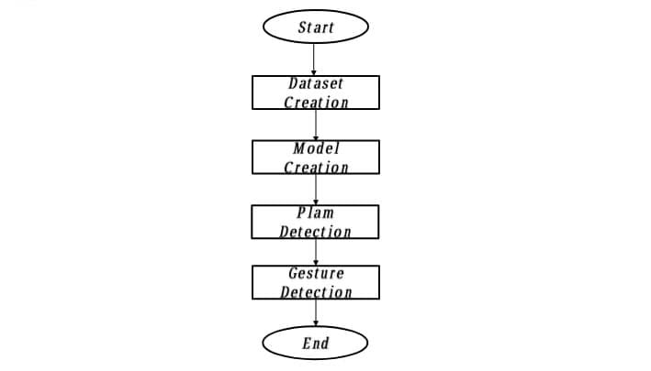

**Modules Formation:**

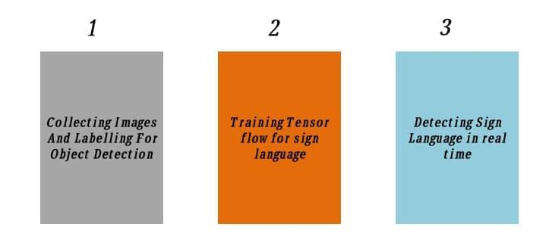

1. **Facilities required for proposed work:** 
   1. Hardware Specification

Laptop or PC 8GB RAM, Graphics Card -6GB, ROM-1060TB, laptop with webcam

* 1. Software Specification

Libraries:

* Numpy
* Open cv
* Tensor flow
* Mediapipe
* Keras
* Data pickle
* GitHub

Programming language: Python

IDE: PyCharm

1. **Conclusion:**

# In this project, we proposed an idea for feasible communication between hearing impaired and normal person with the help of tenser flow and machine learning approach.

# By using OpenCV we can achieve this with high accuracy and fast as well it low cost ever now. Around the world 360 million people are dumb and deaf around the world. We can give a easiest solution and every needed person can use it.

**Bibliography:**

1. J. Ekbote and M. Joshi. "Indian sign language recognition using ANN and SVM classifiers", 2017 IEEE International Conference on Innovations in Information, Embedded and Communication Systems (ICIIECS) 2017
2. P.C. Badhe and V. Kulkarni, "Indian sign language translator using gesture recognition algorithm," 2015 IEEE International Conference on Computer Graphics. Vision and Information Security (CGVIS), Bhubaneswar, 2015, pp. 195-200
3. Nimisha K P and A. Jacob. "A Brief Review of the Recent Trends in Sign Language Recognition" 2020, IEEE International Conference on Communication and Signal Processing (ICCSP), 978-1-7281-4988-2/20 Reaju P Band Kausik, "Hand Gesture Recognition using Deep Root Nodal Architecture, 2019 IEEE 978-1-7281-0089-0/19
4. T. Daphne, M. Kevin," Implementing Gesture Recognition in a Sign Language Learning Application. IEEE 2020 Iris Signals and Systems Conference (ISSC).
5. Nimisha K P and A Jacob, "A Brief Review of the Recent M. Al-Had G. Muhammad, W. Abdul Trends in Sign Language Recognition" IEEE International Conference on Communication and Signal Processing (ICCSP), 978-1-7281-4988-2/20
6. Renju P B and Kausik. "Hand Gesture Recognition using Deep Root Nodal Architecture", 2019 IEEE 978-1-7281-0089-0/19
7. S. Nikam and A. G. Ambekar. "Sign Language Recognition using Image Based Hand Gesture Recognition Techniques" 2016 Online International Conference on Green Engineering and Technologies (IC-GET)

# Submitted By Prof. Priyanka Kanoje

Ms. Pallavi Maske Guide

Ms. Achal Butke

Ms. Sonali Patil

Mr. Chandrakant Prajapati

## Prof. Sarvesh Warjurkar

Head of Information Technology

Tulsiramji Gaikwad-Patil College of Engineering & Technology, Nagpur